TITLE PAGE

Degree Program: BS CIS

Department: Computer and Information Sciences (CIS)

Semester: 1st
Session: 2023 – 2027

Semester Project:

Hangman Game in C

PAKISTAN INSTITUTE OF ENGINEERING AND APPLIED SCIENCES

(PIEAS)


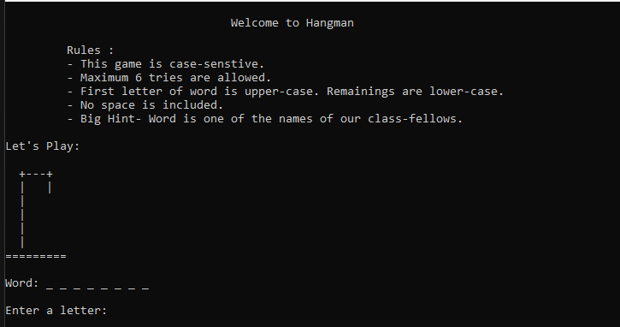
Project Report

Abstract

This is a simple Hangman Game using C Programming Language. We use this Game as a small project to boost our programming skills and understanding logic. The Hangman program randomly selects a secret word from a provided word list. A Hangman Game is about guessing letters to form the words. The word to guess is represented by a row of dashes representing each letter of the word. If the player guesses the right letter that is within the word, the letter appears at its correct position. The user has to guess the correct word until a man is hung. If the user does not guess the correct word, then a man is hung and game is over.

Implementation and Results

Snapshots taken from successful runs of the project code.

Snapshot 1.0 (Output Screen)


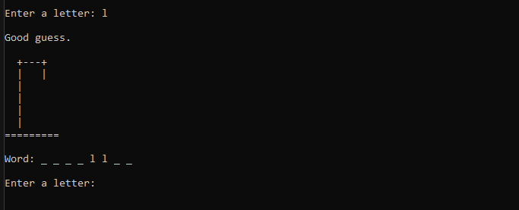
Snapshot 1.1 (true case)


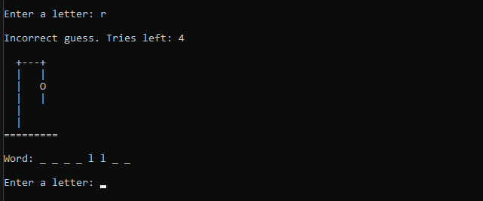
Snapshot 1.2 (false case)


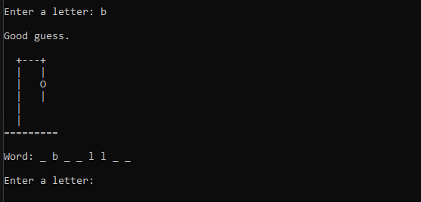
Snapshot 1.3 (true case)


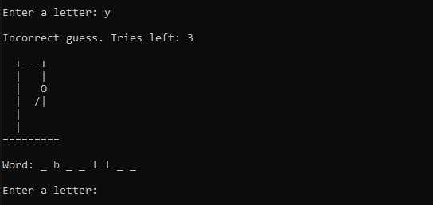
Snapshot 1.4 (false case)


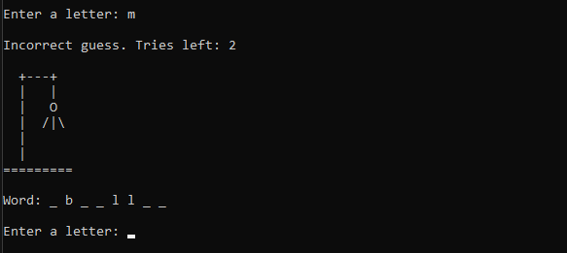
Snapshot 1.5 (false case)


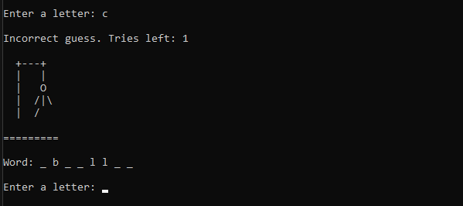
Snapshot 1.6 (false case)


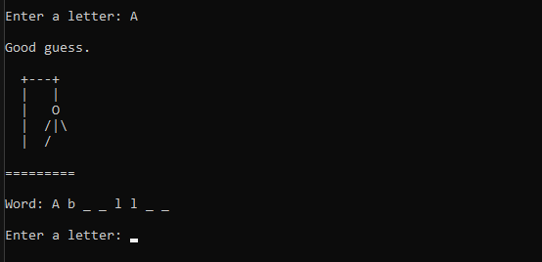

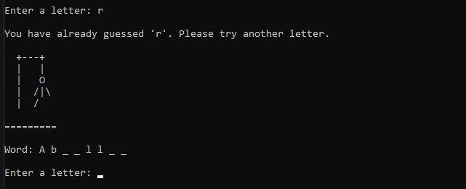
Snapshot 1.7 (true case)

Snapshot 1.8 (repeat case)


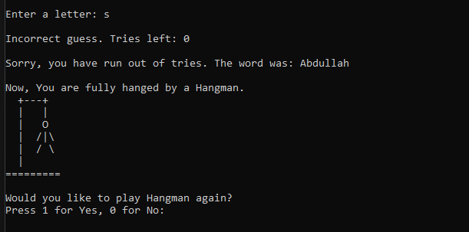

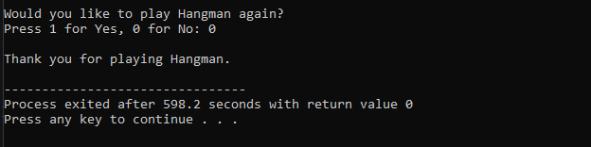
Snapshot 1.9 (end case)

Snapshot 1.10 (last case)

Conclusion

In conclusion, Hangman is a traditional game, typically played with words. It’s possible to play Category Hangman rather than guessing words, the player might guess names of cities, or athletes, or fictional characters, or Duke professors, or top forty song like titles. In simple, the list is endless. We wrote a program to play a “guess a word letter-by-letter” version of hangman as shown above.
The Game we presented is Case-Sensitive. Maximum 6 tries are allowed in one play. First letter of the word is upper-case. Remaining’s are lower-case. No space is included in a guessed word. Big Hint- Word is one of the names of our classmates. If the user enters a word that is already guessed, then the program gives another free try without losing remaining’s tries.
However, by little modification in a source code, we can make the game case-insensitive, change the word-list, change the allocation of tries, give different hints and so on. In simple, we can change the rules of the game and the ASCII Art of hangman game.

